Delivery Document – Formula 1

Kaloyan Rakov

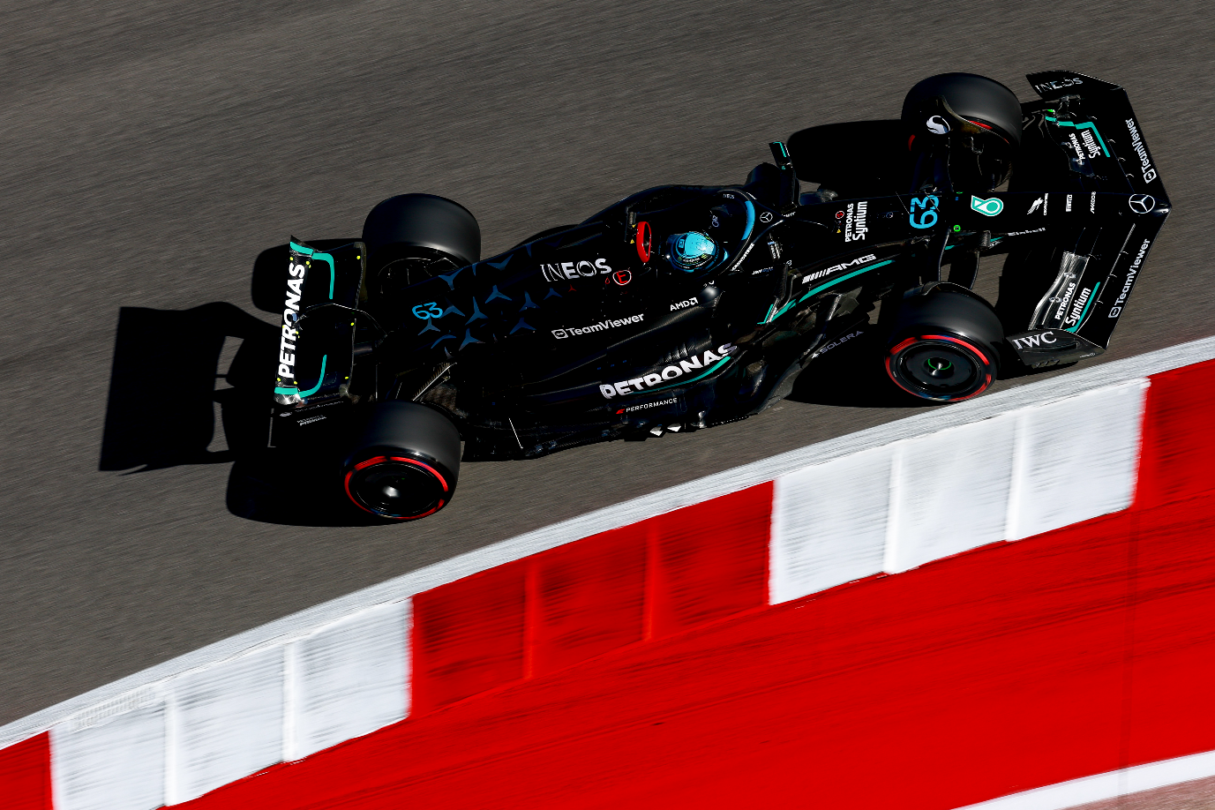



Table of contents

1. Project Overview………………………….
   1. Current State of the Project…………...
   2. Potential Future Improvements……….

1.2.1 Fan-Service Site………………...

1.2.2 Real-Time Probability Updates…

1. Ethical Considerations......…………….….
2. Final Recommendations………………….

3.1 Data Analysis …………………………

3.2 Modelling………………………….….

3.3 Domain Analysis……………………...

4. Sources…………………………………...

1. Project Overview

1.1 Current State of the Project

After the 3rd Iteration of my project, I have reached a level, where using the Data from the 2024 Season, Starting Grid and Qualifying we can make a prediction on a specific race. After predicting all the available races, I have a ranking list for the teams and drivers. The Results can be viewed on the dashboard.

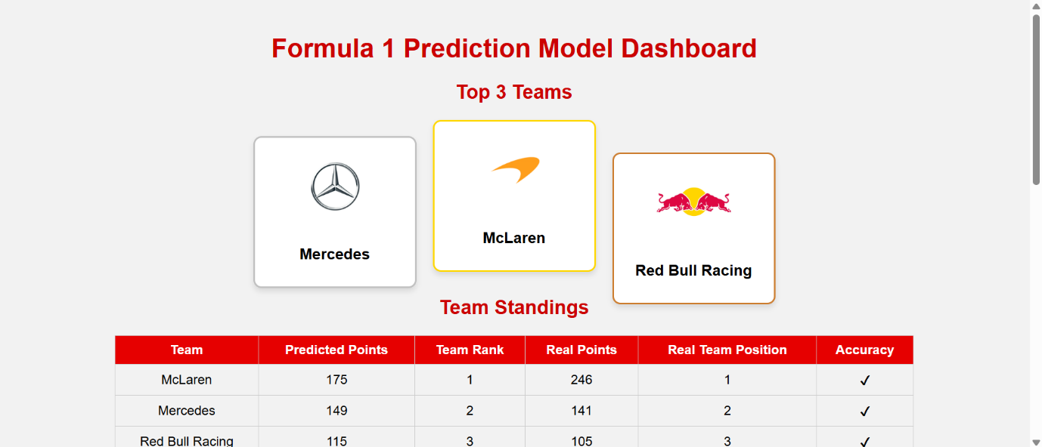

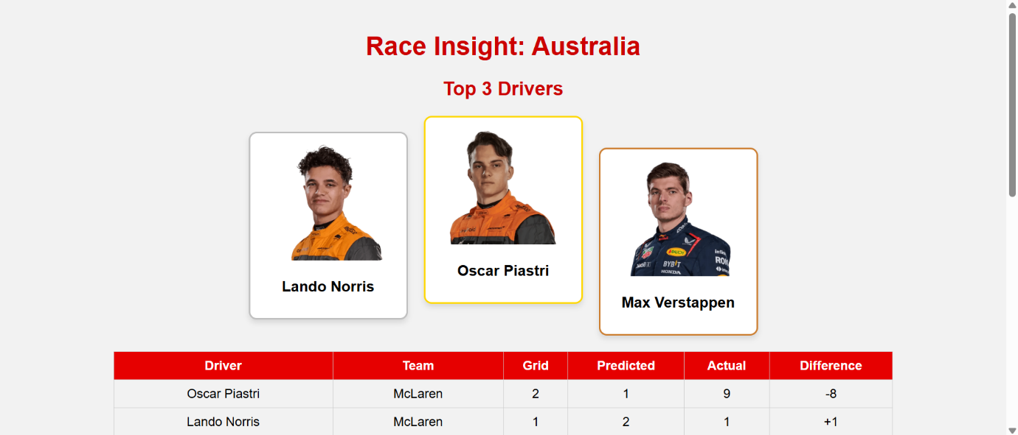

* 1. Potential Future Improvements

Even though that the time limit is over, there are other things that could be implemented in the project.

1. Fan-Service Site:

Inspired by applications like the Ferrari-IBM mobile app designed to deepen fan interaction (IBM Newsroom, 2025), a logical next step would be to create a fan-centric simulation tool. This site would let users customize race conditions—such as the starting grid, and simulate outcomes. Personalized features like following favorite teams or drivers could make race analytics more accessible and fun for fans, while also enabling them to share their own predictions.

Real-Time Probability Updates:

In professional sports like baseball and basketball, live win probability models are widely used. Formula 1 is also beginning to adopt real-time AI systems to react to evolving track conditions such as safety cars, tire degradation, or technical issues (McLaren, 2024). Adding this feature to the project would align it with how modern teams employ real-time analytics during a race (AWS, 2023).

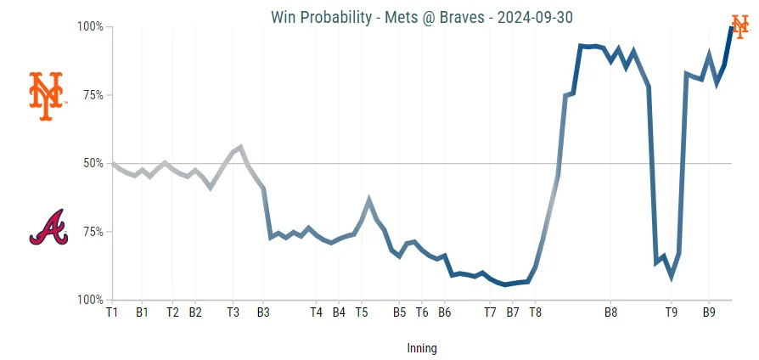

1. Ethical Considerations

As noted by The Race (2024), one key concern is public misinterpretation of AI outputs. If fans or media treat predictions as deterministic rather than probabilistic, it could lead to speculative gambling or clickbait journalism. This project includes disclaimers clarifying that predictions are simulations based on past data and do not account for all real-world uncertainties.

**Public Perception and Bias**

AI-generated insights can unintentionally reinforce biases against certain drivers or teams, particularly if negative predictions are repeated. As Julien Simon-Chautemps notes, AI must be used carefully to avoid creating or amplifying bias in sports reporting and sponsorship decisions (MotorsInside, 2024). Visualizations in this project are therefore accompanied by context, confidence intervals, and limitations of the model.

**Dependency on AI Over Human Judgment**

AI tools should serve as decision helper systems, not decision-makers.  
In a complex and dynamic sport like Formula 1, factors such as team dynamics, weather, or strategy shifts cannot always be captured by data. Therefore, the model should be seen as a supplement to expert analysis, not a replacement. Teams and users should be warned against overreliance on AI, especially in real-time or high-stakes contexts.

3. Final Recommendations

3.1 Data Analysis

In this project we looked at the data from the 2024 season and analysed with the help of graphs. We look into the drivers and teams performances from last season to see if there a favourites for the season we are trying to predict. We look at the tracks with the most NCs and the average time between the drivers for each track to get a better idea of what tracks might prove easier or more challenging. We also take a look at the average time of each driver to get a better idea of how close the competition in Formula 1 is. After we have taken a look at the drivers and the tracks, we look into each driver's performance on each track and look for the relationship between the starting and finishing postition and how it changes through the grid. The visualisation part of this notebook is important since it serves as a way of us to analyze the data before we get into the modeling. This is consistent with how teams like McLaren use AI to process telemetry and historical data to assess performance (McLaren, 2024).

3.2 Modeling

We looked into different types of models: K-Nearest Neighbours, Linear Regression, Descision Trees, Support Vector Regressor and Random Forrest. We applied boosting with AdaBoost or hyperparameter tuning to the models to maximize their efficiency and eventually ended up using the Random Forrest model. After making the predictions, we can compare the predictions with the real-life outcomes either in the notebook or in the website dashboard.

3.2 Domain Analysis

After completing the modeling stage, it's important to reflect on the broader implications of using AI in a high-stakes, data-driven sport like Formula 1. While our prediction model serves as a useful prototype to understand patterns in team and driver performance, it also raises an important question: Should we blindly trust AI? The short answer is no — especially not in isolation.

AI can provide valuable insights, uncover trends, and assist with data-heavy decisions, but it lacks the nuance, intuition, and contextual awareness that human strategists bring to the table. In practice, especially for an F1 team, AI should be seen as an advisor, not a decision-maker. It can help simulate outcomes, evaluate probabilities, and reduce human error in some cases — but final calls should always involve expert judgment, especially given the unpredictable nature of racing.

Looking forward, the role of AI in Formula 1 will almost certainly grow. As data collection improves models will become more and more accurate and possibly even predictive on a per-lap basis. In the context of our project, the model has shown potential and offers a foundation for future development. With more detailed data and advanced features, it could become a practical tool for analysts, teams, and fans alike. But as far as my honest honest advice goes? Treat AI as a co-pilot, not the driver.

4. Sources

**Formula 1 Official Website** – <https://www.formula1.com>  
Used for accessing official driver standings, race results, and historical performance data.

**ChatGPT (OpenAI)** – <https://chat.openai.com>  
Used for generating ideas, reviewing ethical implications.

**Research Materials:**

How is artificial intelligence changing Formula 1? <https://www.autosport.com/f1/news/how-is-artificial-intelligence-changing-formula-1/10659532/>

How Formula 1® uses generative AI to accelerate race-day issue resolution

<https://aws.amazon.com/blogs/machine-learning/how-formula-1-uses-generative-ai-to-accelerate-race-day-issue-resolution/>

Artificial Intelligence: An Inevitable Revolution in Formula 1 According to Julien Simon-Chautemps

<https://www.motorsinside.com/en/f1/news/35805-artificial-intelligence-an-inevitable-revolution-in-formula-1-according-julien-simon-chautemps.html>

How AI is revolutionising F1 - Presented by Dell Technologies

<https://www.mclaren.com/racing/partners/dell-technologies/how-ai-is-revolutionising-f1-presented-by-dell-technologies/>

Inside the tech system and AI policing Formula 1

<https://www.the-race.com/formula-1/inside-the-tech-system-and-ai-policing-formula-1/>

IBM and Scuderia Ferrari HP Debut Reimagined Mobile App to Supercharge Global Formula 1 Fan Experience

<https://newsroom.ibm.com/2025-05-01-ibm-and-scuderia-ferrari-hp-debut-reimagined-mobile-app-to-supercharge-global-formula-1-fan-experience>

AI enters the race to reshape life on and off the track

<https://www.ft.com/content/3586067f-27c3-4f62-946d-670585ae830d>

The future of F1: How AI and cutting-edge tech are revolutionizing the sport

<https://timesofindia.indiatimes.com/sports/formula-one/news/the-future-of-f1-how-ai-and-cutting-edge-tech-are-revolutionizing-the-sport/articleshow/118406036.cms>